R. Reports Menu: N. Preprinted Tax Forms

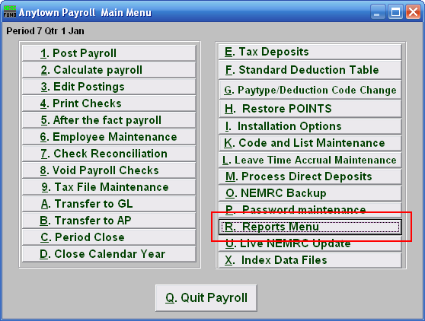
Click on “R. Reports Menu” from the Main Menu and the following window will appear:

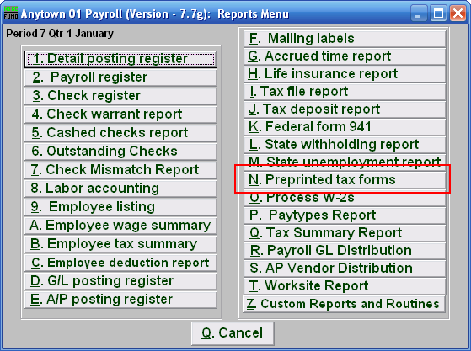

Click on “N. Preprinted tax forms” from the Reports Menu and the following window will appear:
Preprinted Tax Forms

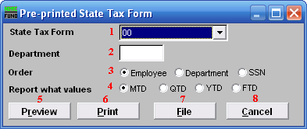
- State Tax Form: Select the form to complete from the drop down menu..

- Department: Select the Department you want this report to be for.

- Order: Employee OR Department OR SSN: Click to choose whether this report prints in order of Employee number, Department, or in order of Social Security Number.

- Report what values: Select one of the following:
MTD = Month to Date
QTD = Quarter to Date
YTD = Year to Date (calendar)
FTD = Fiscal to Date

- Preview: Click this button to preview this report. Refer to GENERAL PREVIEW for more information.

- Print: Click this button to print this report. Refer to GENERAL PRINTING for more information.

- File: Click this button to save this report on this computer. Refer to GENERAL FILE for more information.

- Cancel: Click “Cancel” to cancel and return to the previous screen.

